Curriculum Vitae

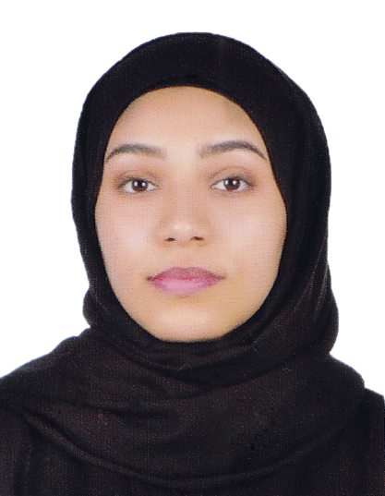

**Personal Details:**

**Name:** Ghffran Jaffar Ahmed. **Address:** Sitra, Kingdom of Bahrain.

**Nationality:** Bahraini. **Mobile**: +973 37281188

**Date of Birth:** 31 – 10 – 1999 **Email:** ghffran.jaffar@gmail.com

**Gender:** Female. **CPR:** 991011210

**Marital:** Single.

**Objectives and Goals:**

I am seeking a job where I can use my experience and education to help meet surpass its goals. I want a highly rewarding career where I can use my skills, share my knowledge, views and opinions to help the company and my coworkers to be successful.

**Educational and Background:**

**#** 2011 – 2014 Certification of Intermediate

From Sitra Intermediate School.

**#** 2014 – 2017 Secondary Commercial Certification

From Sitra Secondary School.

**Skills:**

_ Quick typist.

_ Capable of learning new material.

**_** Excellent in Microsoft office applications ] word & power point [

**Languages:**

**_ Arabic:** Native.

**_** **English:** Good.

**Interest and activities:**

**_** Reading.

**_** Volunteer work.